LAB – 3 JAVA

BOOK

NAME: AFREEN ANZ

1BM23CS016

Create a class Book which contains four members: name, author,

price, num_pages. Include a constructor to set the values for the

members. Include methods to set and get the details of the objects.

Include a toString( ) method that could display the complete details of

the book. Develop a Java program to create n book objects.

OUTPUT: 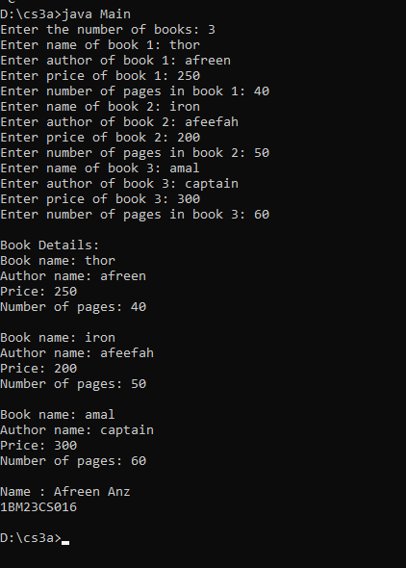

SOURCE CODE:

import java.util.Scanner;

class Book {

// Class members

String name;

String author;

int price;

int numPages;

Book(String name, String author, int price, int numPages) {

this.name = name;

this.author = author;

this.price = price;

this.numPages = numPages;

}

public String toString() {

String bookDetails = "Book name: " + this.name + "\n" +

"Author name: " + this.author + "\n" +

"Price: " + this.price + "\n" +

"Number of pages: " + this.numPages + "\n";

return bookDetails;

}

}

public class Main {

public static void main(String[] args) {

Scanner s = new Scanner(System.in);

System.out.print("Enter the number of books: ");

int n = s.nextInt();

Book[] books = new Book[n];

for (int i = 0; i < n; i++) {

System.out.print("Enter name of book " + (i + 1) + ": ");

String name = s.next();

System.out.print("Enter author of book " + (i + 1) + ": ");

String author = s.next();

System.out.print("Enter price of book " + (i + 1) + ": ");

int price = s.nextInt();

System.out.print("Enter number of pages in book " + (i + 1) + ": ");

int numPages = s.nextInt();

books[i] = new Book(name, author, price, numPages);

}S

System.out.println("\nBook Details:");

for (Book book : books) {

System.out.println(book);

}

s.close();

System.out.println("Name : Afreen Anz\n1BM23CS016");

}

}